1. Install MySQL
2. create database test;
3. create 3 tables by using below quereies

A.

CREATE TABLE test.CUSTOMER (

customer_id BINARY(16) DEFAULT (UUID()) PRIMARY KEY,

customer_name VARCHAR(255) NOT NULL ,

customer_slug VARCHAR(255) NOT NULL default ""

);

B.

CREATE TABLE test.PARCEL (

parcel_id INT AUTO_INCREMENT PRIMARY KEY,

origin_country_id VARCHAR(255) NOT NULL ,

destination_country_id VARCHAR(255) NOT NULL ,

weight float NOT NULL,

created_at datetime Not NULL,

customer_id BINARY(16) Not NULL,

tracking_Number VARCHAR(255) default "",

count int not null,

foreign key (customer_id) references CUSTOMER(customer_id)

);

C.

CREATE TABLE test.TRACKING (

tracking_Number VARCHAR(255) PRIMARY KEY,

parcel_id INT Not NULL,

foreign key (parcel_id) references PARCEL(parcel_id)

);

4. Edit DB details in Springboot Application.properties file as per the installed db credentials

spring.datasource.url=

jdbc:mysql://localhost:3306/test?useSSL=false&serverTimezone=UTC

spring.datasource.username=root

spring.datasource.password=password

spring.jpa.properties.hibernate.dialect=org.hibernate.dialect.MySQLDialect

5. Start the application

4. First Create Customer and Parcel in DB using the below APIS

Note : Calling APIS in postman

A.

Create customer in DB by calling below API

Method: Post

URL: http://localhost:8080/application/createCustomer

Input :

{

   "customerName":  "Sameena Logistics",

    "customerSlug" : "sameena-logistics"

}

Output:

{

    "customerId": "46d98356-a7f2-4663-80c1-8ca29c539983",

    "customerName": "Sameena Logistics",

    "customerSlug": "sameena-logistics"

}

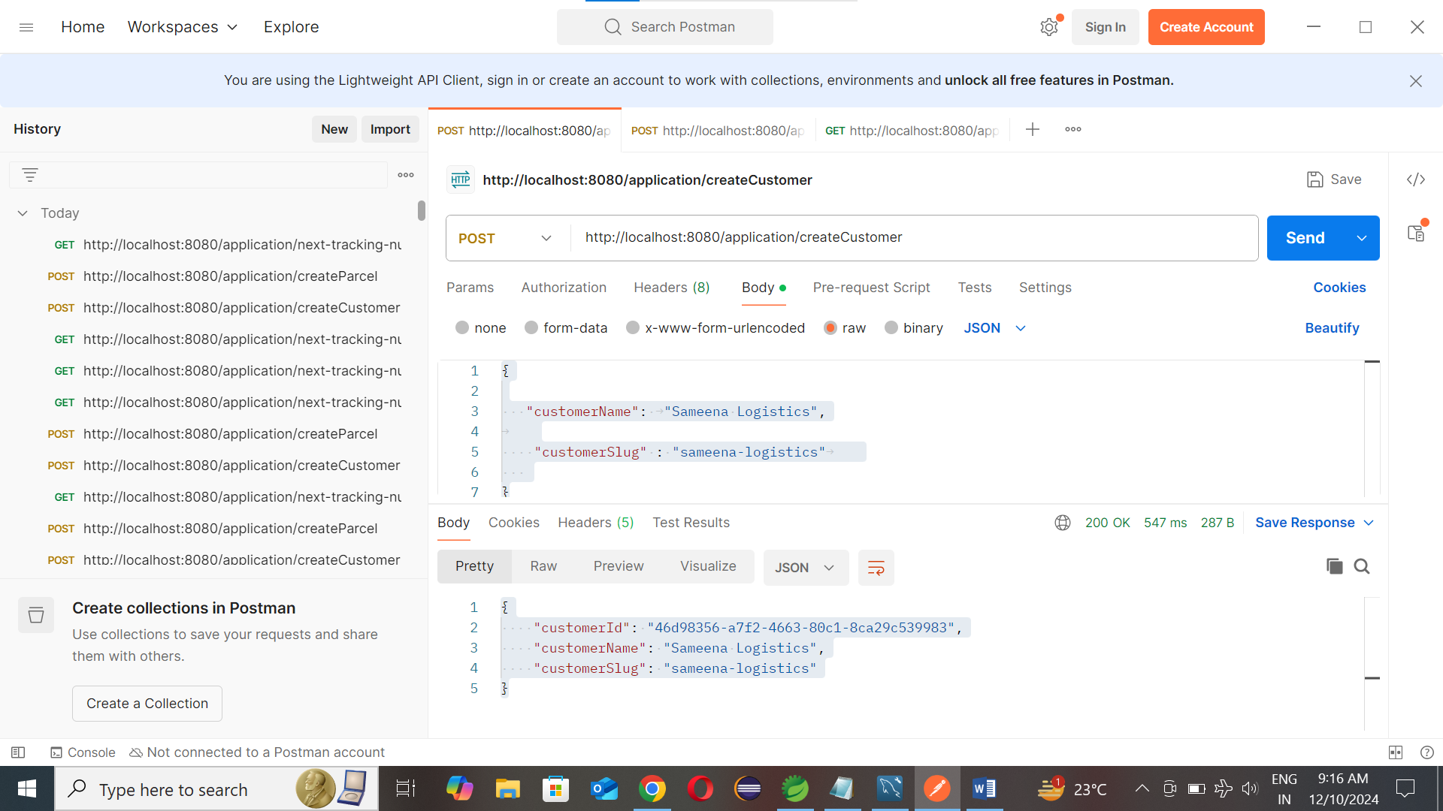

B.

Create Parcel in DB by calling below API

Method: Post

URL: http://localhost:8080/application/createParcel

Input :

{

    "originCountryId": "MY",

     "destinationCountryId" : "SG",

     "weight": 100,

    "customerId":"46d98356-a7f2-4663-80c1-8ca29c539983"

}

Note : Take customerID from the firstAPI Response

Output:

{

    "parcelId": 12,

    "originCountryId": "MY",

    "destinationCountryId": "SG",

    "weight": 100.0,

    "createdAt": "2024-12-10T09:09:14-08:00",

    "trackingNumber": "46d98356-a7f2-4663-80c1-8ca29c539983-12-2024-12-10T09:09:14-08:00-1",

    "count": 1,

    "customer": {

        "customerId": "46d98356-a7f2-4663-80c1-8ca29c539983",

        "customerName": "Sameena Logistics",

        "customerSlug": "sameena-logistics"

    },

    "customerId": "46d98356-a7f2-4663-80c1-8ca29c539983"

}

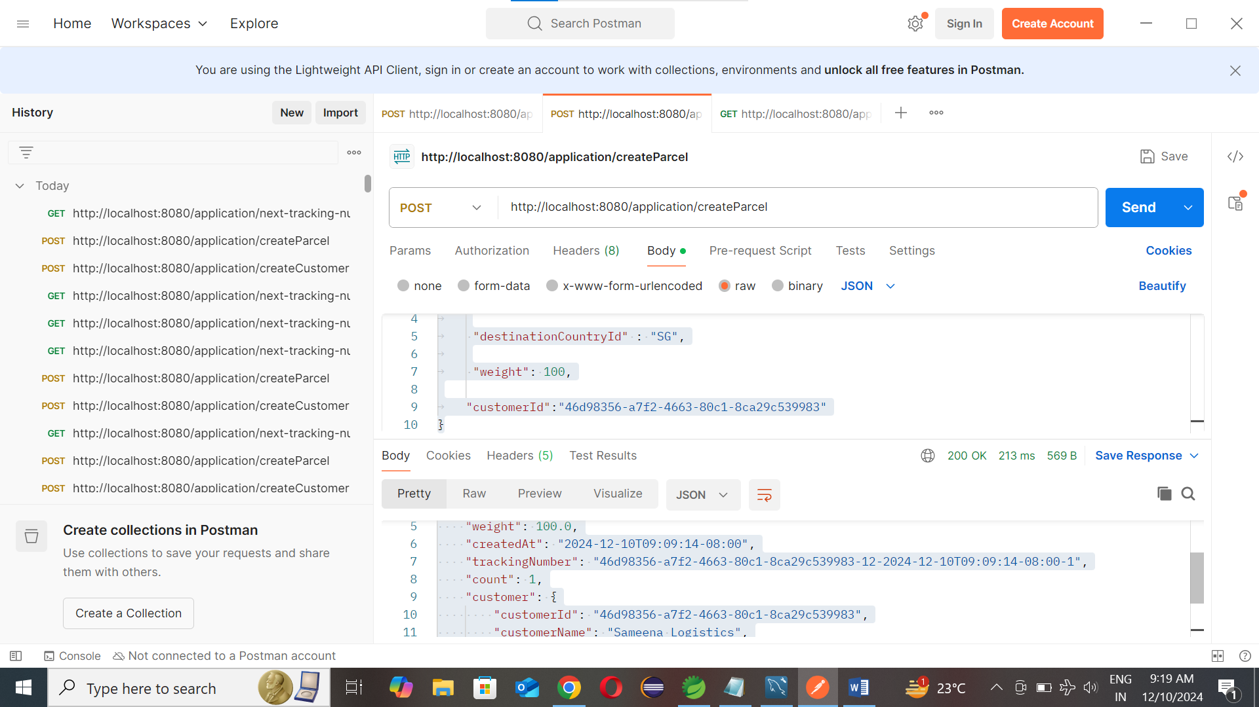

C.

Generate next tracking number for the parcel by calling below API

Method: GET

URL: <http://localhost:8080/application/next-tracking-number>

Input :

{

   "customerName":  "Sameena Logistics",

    "customerSlug" : "sameena-logistics"    ,

    "originCountryId": "MY",

     "destinationCountryId" : "SG",

     "weight": 100,

    "customerId":"b6d4e51b-5a13-4081-8f57-e379b43ac336"

}

Output :

{

    "createdAt": "2024-12-10T09:42:38-08:00",

    "trackingNumber": "b6d4e51b-5a13-4081-8f57-e379b43ac336-13-6"

}

Note : Same input data CAN be submitted , every time it generates unique tracking number for the parcel.

Note:

Formula for Tracking Number :

customerID - parcelID-parcelcount

Each parcel has count column while will be incremented in every tracking number request.

